HR and Managerial Rounds Questions

(the answers of these questions are just samples to get and idea😀)

1). Tell me about yourself/Introduce yourself.

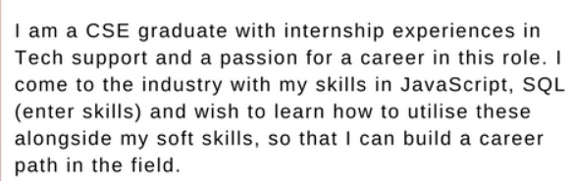

* “Sir, my greatest strength is my ability to learn things quickly. For example, I had to represent my college in an inter college science exhibition, and was introduced to the team at the very last minute. I was able to understand our exhibits and artifacts and present them with great success”.
* “I think my greatest strength is my positive attitude, even during the hardest of times. During my college project, there has been a couple of occasions, when our idea was not falling in place and the results were negative. I had to believe and think positively and keep my team motivated to persist on our idea, and finally we got the desired result.”
* “My best skill would be my verbal ability and articulation skill. I have worked as editor for our college magazine and have been involved with various literary forms during my school and college days.

2).Tell us about your family.

(Simple question, just to tell them in a good way 😀)

3).What is your favourite subject and why?

(There is a high probability that most of the questions they ask will be from the subject you mention.)

This question can only be answered by you.

Your favourite subject is the one you feel relaxed in, the one you feel energetic with, the one in which you can spend hours without getting tired and the one in which you get excited the most.

Sometimes, the subject you think you love is not the subject which can be your favourite. For example I love to write poems, articles and books but still language is not my favourite subject. I hate language all because of grammar, writing skills and punctuation marks. Still I have evolved my language from very poor to above average.

I will tell you,

I love science, mainly chemistry, physics and at last biology, I have less interest in biology even though it is really interesting. Most of the times, my friends ask me-

1. Are you a nerd?
2. Why do you love chemistry?
3. Don’t you get bored solving these numericals?
4. Are you sure you love solving these chemical reactions?
5. When was the last time you picked up your nose off chemistry?
6. Do you dream about compounds?

I laugh at their questions… If I am comfortable in this subject it is because it interests me. What’s the problem man! There are some kids who love maths. So the subject that interests you the most is your favourite subject, even if you score bad in it..

I hope you understood what I mean…

(ref:quora)

4).Tell us about your strengths and weaknesses.

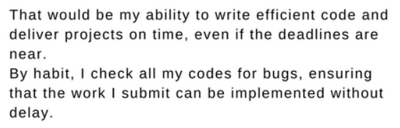

Weakesess:

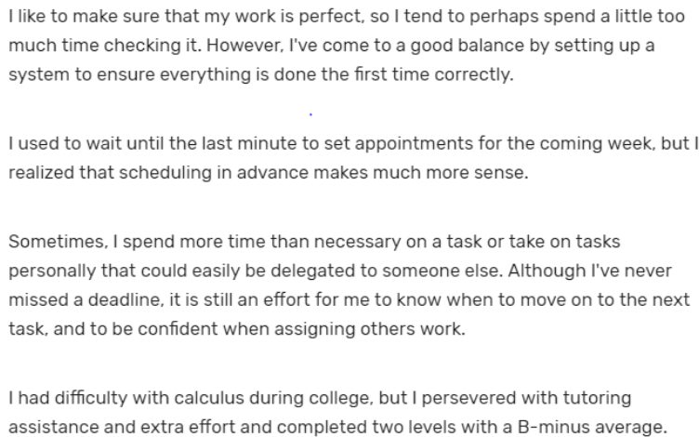

(It is good not to say like I get emotional very fast or anger etc etc because we will come through many situations which we have to deal with and that can’t be done with emotions or anger😀)

5). What motivates you?

## Possible Answer #1

*“My biggest motivation is family. They are my biggest source of inspiration and my strongest supporters as well. When I see my parents working, it gives me the drive to be like them. Their dedication to working is what motivates me to be like them. They are self-motivated individuals. Hence I try to imbibe their positivism into my life. I have learned from my father how to not give up on a tough client. The essence is to go through the grind to really know what the other person wants. This excites me to take up greater challenges and risks without the fear of failure or backing out. My mother is the source of calm confidence. Knowing exactly where to push hard and where to slow down is something I have imbibed from her. They remain, my go-to people, when I feel under the weather or less motivated.”*

## Possible Answer #2

*“Success is what motivates me to do a good job. Knowing the fact that my hard work and perseverance will help me achieve greater professional success is what keeps me going. I feel that aligning the company’s vision and values with my own is one way to achieve that. When I know that my efforts are following the correct path, it encourages me to push more. Hence, for me, success is important both at a personal as well as at an organizational level. Motivation is seeing the organization grow which ultimately leads to personal achievement and success. There might be instances of failure or stagnation but it does not demotivate me anyhow. On the other hand, I feel re-invigorated to perform even more. The taste of success after a failure is what keeps the fire going within me no matter what the circumstance.”*

(For more : <https://www.naukri.com/blog/what-motivates-you-to-do-a-good-job-sample-answers-to-this-hr-interview-question/#:~:text=%E2%80%9CSuccess%20is%20what%20motivates%20me,one%20way%20to%20achieve%20that.>)

6).What do you mean by ethics?

*"Several years ago in my first role as a retail associate, I witnessed a coworker taking cash from one of the registers. At first it looked just like changing over the drawer, but I decided to confront the staff member anyway. The employee was actually taking money from the register, and I took the cash they had from the drawer, placed it back in the register and notified my supervisor. We were able to resolve the issue through balancing the cash drawer and ensuring that particular employee was unable to commit theft from the company again."*

*"At the end of my freshman year, we were taking our final exams, and I saw one of my classmates cheating on the exam. I understood the challenge that the exam posed, and I knew that failing the exam could affect our GPA. However, I also don't believe it's ethical to achieve success at the expense of others, and at the end of the class session I alerted my professor to what I saw. I explained that although I know the consequences of failing, and even more so with cheating, I couldn't stand to let someone plagiarize another's work."*

*(For more:* [*https://www.indeed.com/career-advice/interviewing/ethical-interview-questions*](https://www.indeed.com/career-advice/interviewing/ethical-interview-questions)*)*

*7).What do you know about tcs?*

*Ans.*

|  |
| --- |
| *TCS (Tata Consultancy Service) Limited is an Indian multinational company which deals in consultancy service and Information technology. It is headquartered in Mumbai, India. It is a part of the Tata group and operates in 46 countries.*  *TCS is one of the largest Indian companies by market capitalization and one of the most trusted Indian brands worldwide. It alone generates 70% of the dividends of its parent company Tata Sons.*  *Recently, Tata Sons decided to sell stocks of TCS worth $1.25 billion in a bulk deal. In 2015, TCS was ranked 64th overall in the Forbes World's Most Innovative Companies ranking, making it both the highest-ranked IT services company and the top Indian company.*  *TCS is the world's 2nd largest IT services provider. In 2017, TCS is ranked 10th on the Fortune India 500 list. In April 2018, TCS became the first Indian IT company to breach $100 billion market capitalization.*  *(please do give this question importance and do some more research about the company and if possible update it here also😀)*  *8).Why should we hire you?*  *The requirement for this job completely matches my skill set, as a candidate I have experience working in this domain which might be beneficial for the organization as well as me. Also, I am a quick learner and a team player so the organization won't have to spend much time and resources on me. Even when I work, I work for the maximum benefit of the organization. Moreover, I would gain exposure to the industry which will be very beneficial to my career.* |

*9). Are you willing to relocate / work in different shifts?*

*Yes, as part of growing up I used to travel a lot as my father is an ex-serviceman hence occasionally he used to be posted throughout the country. Though I would prefer my city as it helps me live with people I care about, but at the same time, I am ok with relocating.*

*10).Where do you see yourself in next 5 or 10 years?*

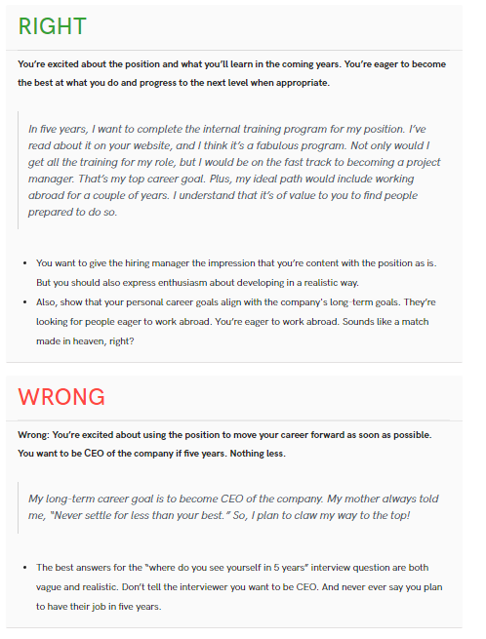

*11).How do you solve a complex task.*

*(ref:* [*https://biginterview.com/behavioral-interview-question-problem-solving/#:~:text=Tell%20me%20about%20a%20situation,duty%20to%20get%20things%20done.*](https://biginterview.com/behavioral-interview-question-problem-solving/#:~:text=Tell%20me%20about%20a%20situation,duty%20to%20get%20things%20done.)*)*

*12).What is the difference between smart work and hard work?*

*The difference between hard work and smart work is based on how I approach my task. Hard work would mean spending long hours to complete my work without any shortcuts. It definitely ensures results but the process is long and stressful. Smart work would be aiming for the same results but with planning and prioritization of tasks. In College/Law School, the trend of examination questions was repetitive. The questions asked in the last few years would be asked again. I realised this after my first semester. Since then, for the examinations, I would only study the previous 5 years’ questions. For the rest of the year, I would focus on studying everything else. Therefore I worked hard to study the entire syllabus for my own knowledge and worked smart to score well in my examinations. A combination of both has guaranteed me the best possible results always!*

*(ref:*[*https://www.naukri.com/blog/difference-between-hard-work-and-smart-work-how-to-answer-this-hr-interview-question/#:~:text=The%20difference%20between%20hard%20work%20and%20smart%20work%20is%20based,my%20work%20without%20any%20shortcuts.&text=Smart%20work%20would%20be%20aiming,planning%20and%20prioritization%20of%20tasks.*](https://www.naukri.com/blog/difference-between-hard-work-and-smart-work-how-to-answer-this-hr-interview-question/#:~:text=The%20difference%20between%20hard%20work%20and%20smart%20work%20is%20based,my%20work%20without%20any%20shortcuts.&text=Smart%20work%20would%20be%20aiming,planning%20and%20prioritization%20of%20tasks.)*)*

*13).How do you handle team conflicts.*

*(*[*https://www.indeed.com/career-advice/interviewing/handle-conflict-in-workplace*](https://www.indeed.com/career-advice/interviewing/handle-conflict-in-workplace)*)*